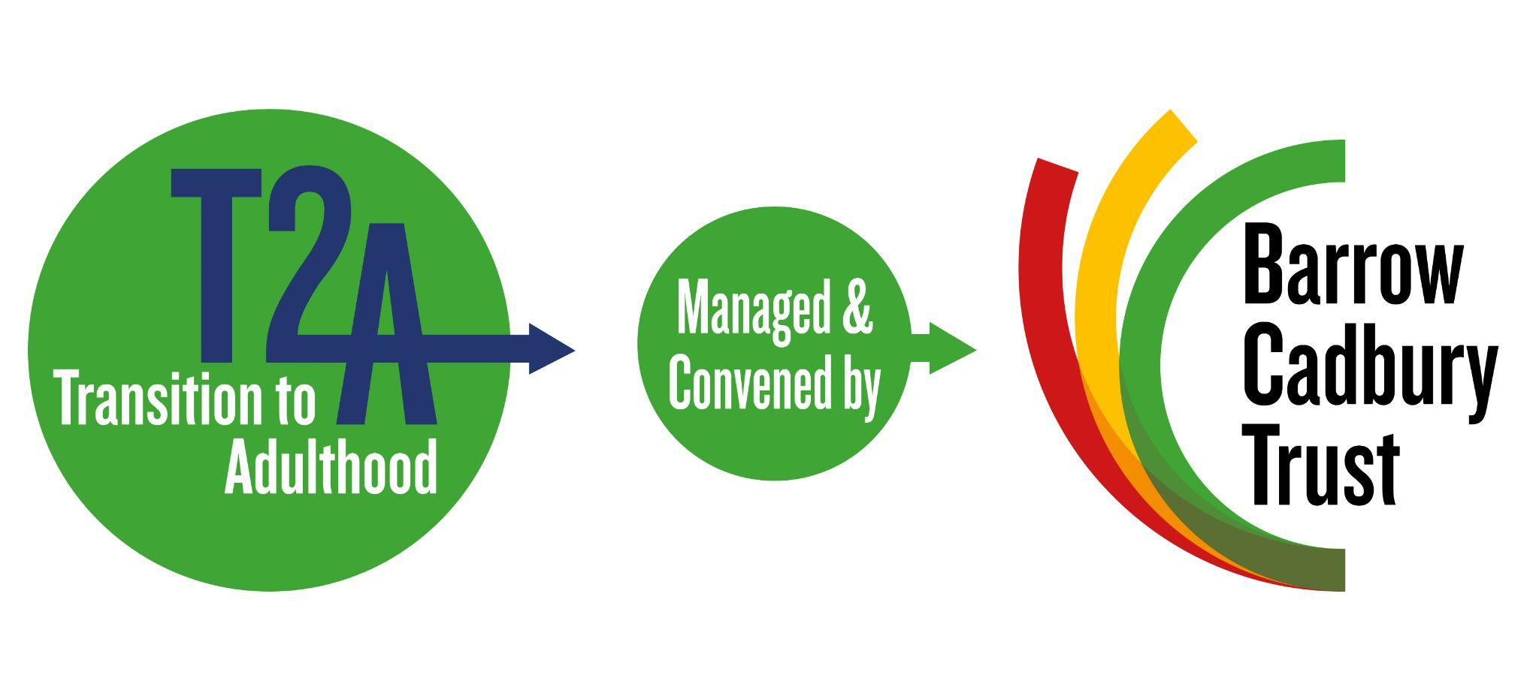

Re. Her Majesty’s Inspectorate of Probation’s [Consultation on: Probation Inspection Standards](https://www.justiceinspectorates.gov.uk/hmiprobation/wp-content/uploads/sites/5/2022/07/Consultation-on-probation-inspection-standards.pdf)

**Consultation Response from the Transition to Adulthood Alliance, 16 August 2022**

The Transition to Adulthood (T2A) Alliance evidences and promotes effective approaches for young adults (18-25) throughout the criminal justice system (CJS). T2A has contributed to positive change in policy and practice at central and local levels, and its evidence has informed service redesign and delivery nationally and internationally. It is an alliance of 12 leading criminal justice, health and youth organisations including: Addaction, Care Leavers’ Association, Black Training and Enterprise Group, Catch22, Centre for Crime and Justice Studies, Clinks, Criminal Justice Alliance, the Howard League for Penal Reform, Nacro, Prisoners Education Trust, Prison Reform Trust, Police Foundation, Revolving Doors Agency and Together for Mental Wellbeing. It is convened and funded by the Barrow Cadbury Trust[1].

T2A welcomes the opportunity to respond to this consultation, and would happily respond to any follow up enquiries.

**Q1. Should we inspect and rate regional arrangements and activity against domain one**

**standards?**

T2A believes HMI Probation should inspect and rate regional arrangements and activity. We view the proposals as positive. Our hope is that they will allow inspections to shed light on how effectively probation services are engaging at a regional level with cohorts that have disproportionately poor outcomes - including young adults - and how these outcomes could be improved. We agree with [HMI Probation’s evidence base on young adults](https://www.justiceinspectorates.gov.uk/hmiprobation/research/the-evidence-base-probation/specific-sub-groups/young-adults/) and believe ‘the combination of high offending and high potential for desistance supports a focus on [young adults]’.

The ‘volume of crime committed by this age group is higher than for any other adult age group’ - and the evidence base emphasises the potential for ‘large reductions in the total number of crimes committed’[2] should this group receive the support they need. We believe this potential can be realised - with the help of inspections, cross-cutting, innovative recommendations, the showcasing of best practice, and better use of levers for change at regional and national levels.

**Q4. What evidence should we draw on to make judgements against the regional standards?**

*Young adult-specific insights*

Probation Delivery Units hold a wealth of information which could be used to develop a region-wide view of how diverse groups - including young adults - are supported and encouraged to desist from crime. T2A would like to see the Inspectorate place greater emphasis on whether the Equality Act 2010 is adhered to, especially in relation to the protected characteristic of age. An effective means of doing this could involve HMI Probation examining risks, needs and outcomes data for different cohorts, and aggregating this at regional level. This will help identify regional differences in the treatment and outcomes of individual cohorts - including young adults, women and racialised groups. These differences could be further scrutinised and used to help shape priorities, secure strategic benefits, and drive progress toward developing a flexible, responsive probation system.

The recent thematic inspection on [‘Race Equality in Probation’](https://www.justiceinspectorates.gov.uk/hmiprobation/inspections/race-equality-in-probation/) and resulting changes, provide a helpful blueprint for how the Inspectorate can collate useful evidence and assess cohorts. This was a national thematic report. And though we would welcome a national report on young adults, we also see the potential in developing regional analysis which can be aggregated to better identify and inform national themes. Thematic analysis on young adults can also help drive progress toward HMI Probation’s race-focused objectives. Young adults are disproportionately from BAME backgrounds[3], and an intersectional approach would be needed to ensure BAME young adults receive holistic, effective support.

In assessing the support and outcomes of individual groups, like young adults, HMI Probation can paint a more nuanced picture of service standards - whether they are being met, and if not, why not. For example, regional service standards highlight reducing reoffending as a priority. HMI Probation’s own evidence base acknowledges that young adults ‘are at a pivotal moment in their capacity for offending and desistance from crime’, and ‘are [at] the age where most of those that desist from crime begin to do so’. And yet, in the UK, young adults have one of the highest reoffending rates[4] and represent 22% of the probation caseload[5]. This suggests that some services are less effective in promoting desistance for this group. T2A believes that this is partially due to the limited emphasis placed on creating and evaluating developmentally and age-appropriate models of support and interventions. A closer, region-wide examination of this group’s engagement with services could lead to recommendations which could increase the effectiveness of desistance programmes, and substantially reduce reoffending rates.

The logic set out in the consultation document regarding statutory victim work can also be applied to judgements related to young adult work. In any inspection sample period, a PDU might be overseeing a small number of young adults and/ or ‘youth to adult’ transition cases. Inspecting at a regional level could help ensure there are a sufficient number of cases to form the basis of a judgement - which in turn would add more weight to recommendations and allow for secondary analysis. We would like to see data from larger regional samples collated and presented in a form which breaks down young adult data even further - highlighting the distinct needs and outcomes of young adults at the intersections of race and gender.

*Safeguarding*

T2A sees value in safeguarding being a priority during regional assessments but we believe greater value could be realised if a broader, more inclusive interpretation of safeguarding were used. With regional assessments, there’s an opportunity to better understand the contextual safeguarding and transitional safeguarding needs of young adults and how they are applied in practice. HMI Probation-commissioned Academic Insights stress: “it is increasingly clear that binary notions of childhood versus adulthood, and of vulnerability versus culpability, do not reflect the complexity and interconnectedness of young people’s lives”[6].

Between the ages of 18 and 25, young adults are particularly vulnerable to exploitation. This is because their level of psycho-social maturity and their stage in brain development means that they are more susceptible to peer pressure and less skilled at forward planning and understanding consequences. The cliff-edge in social support that many experience on their 18th birthday can also increase this vulnerability.

A binary approach to safeguarding, makes it difficult to accurately gauge how many young adults are subject to criminal exploitation. Their vulnerability is clouded when the CJS seeks to punish rather than protect them. The human cost of this binary approach is high - especially for those who turn 18 before their offence and conviction. Those who turn 18 lose their anonymity, have a reduced likelihood of diversion, are only being eligible for adult sentences, and have longer supervision periods (heightening risk of breach)[7].

The approach also risks costs to the Ministry of Justice (MoJ). A Judicial Review was recently brought against the Secretary of State for Justice by ATLEU[8]. The Secretary of State acknowledged the department’s shortcomings in criminal exploitation policy and the identification of victims - and ultimately settled the JR claim in July 2022. Assessing a region’s capacity to provide contextual and transitional safeguarding is key to providing young adults with the protections they need and are, in some cases, legally entitled to under the Modern Slavery Act - mitigating the risk of legal challenge to the MoJ. Inspectors could examine NRM referrals at a regional level and subsequent support offered to those identified - and shed light on safeguarding measures which could keep victims and the public safe.

**Q8. In addition to evidence about PDU staffing what other evidence should we use in making judgements about staffing at a regional level?**

T2A would like to see further assessment of specialist training opportunities provided at regional level, whether staff can realistically access them and how they are supported to put their learning into practice. For example, this might involve inspectors examining evidence on whether managers are actively encouraging participation in training, reviewing learning within teams, and protecting time for staff to engage. This would also provide insights into leadership considerations.

Aggregating data from the workload management tool at a regional level should provide helpful evidence too. Our work with probation officers focused on young adults has highlighted that managing this cohort can be time and resource intensive. This stems from young adults needing additional support to navigate the transition into adulthood and to deal constructively with the challenges they may face in desisting from crime. We have heard that the workload management tool does not fully account for this intensity. A regional picture of workloads could identify areas which are most under-resourced in a region and help support prioritisation and funding decisions.

1. <https://t2a.org.uk/>
2. ‘The Evidence Base - Probation Services: Young Adults’, Her Majesty’s Inspectorate of Probation (2021)
3. ‘The Young Review: Improving outcomes for young black and/ or Muslim men in the Criminal Justice System’, Lola Young (2014)
4. ‘The treatment of young adults in the criminal justice system (Seventh Report of Session 2016–17)’, House of Commons Justice Committee (2016)
5. ‘The Evidence Base - Probation Services: Young Adults’, Her Majesty’s Inspectorate of Probation (2021)
6. ‘HMI Probation Academic Insights 2022/23 - Transitional Safeguarding’, Dez Holmes and Lisa Smith (2022)
7. ‘Timely Justice: Turning 18 - A briefing on the impact of turning 18 in the criminal justice system’, Victoria Haylar-Cardwell (2020)
8. ‘New modern slavery guidance for prison staff - R (ATLEU and QW) v Secretary of State for Justice)’, Anti-Trafficking and Labour Exploitation Unit (2022)